PHYS 212 PreLab 4 Name ______________ ID_____________________
Q1[10’] For each situation listed below, state whether the two poles will attract or repel each other when brought close together.
north pole & north pole ________________________________
north pole & south pole ________________________________
south pole & south pole ________________________________

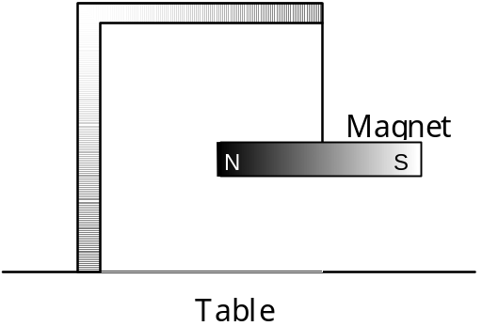

Figure 2. A magnet suspended by a string
Q2[10’] Suppose a stationary bar magnet is placed directly underneath the suspended magnet, as shown in Figure 2. Draw the final alignment of the suspended magnet on Figure 3.
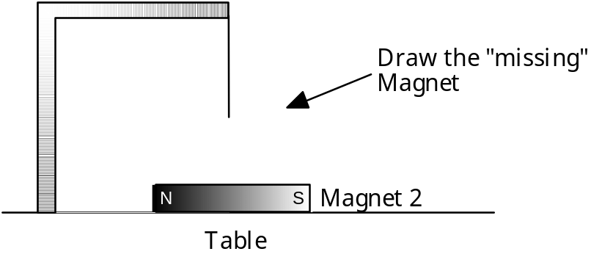

Figure 3. The situation of Question 2
You can also think of the problem in terms of field lines. The stationary magnet in Figure 3 generates magnetic field lines, pointing from its north pole to its south pole. The suspended bar magnet then aligns itself along those lines.
Q3[10’] Draw a few field lines in Figure 3, indicating the direction of the B field created by the stationary bar magnet. Once the suspended magnet has aligned itself with the magnetic field, which of its poles points in the same direction as the external field produced by Magnet 2?
___________________________________________________________
___________________________________________________________

The compass needle is nothing more than a tiny bar magnet, with its north pole indicated in some way (often with the letter 'N', or with a red color).
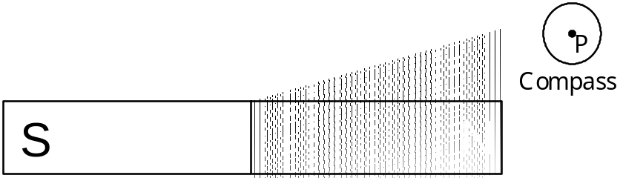

Figure 4. Draw the compass arrow through point P

Q4[10’] In Figure 4, a compass is placed at point P near a bar magnet. Draw an arrow in the direction that the north pole of the compass would point at point P. (Hint: You may want to first sketch in the field generated by the large magnet.)

Q5[10’] The north pole of a compass always points to near the geographic North Pole of the earth. What sort of magnetic pole therefore exists near the geographic North Pole of the Earth?
___________________________________________________________
___________________________________________________________

When discussing the electric field we made use of the concept of a positive test charge. For a magnetic field we will use a similar idea, a test compass. By definition, the magnetic field at point P points in the same direction as the north pole of the compass.

